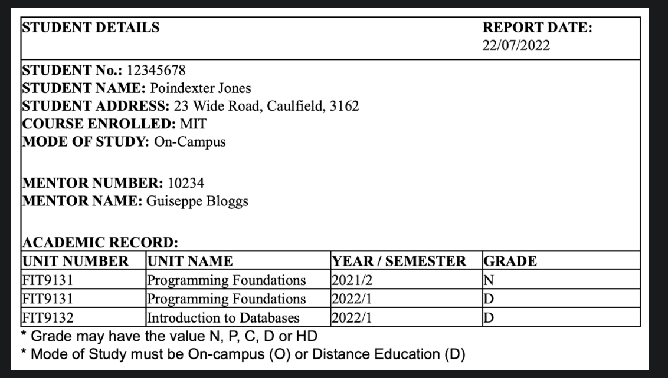

**UNF  
STUDENTDETAILS(**stu_no, stu_name, stu_addr, course_enrolled, modeOfStudy, mentor_no, mentor_name(**ACADEMIC_RECORD**(unit_no, unit_name, year, grade)) **1NF  
STUDENTDETAILS(**stu_no, stu_name, stu_addr, course_enrolled, modeOfStudy, mentor_no, mentor_name)  
  
**ACADEMIC_RECORD**(unit_no, unit_name, year, grade, stu_no) **2NF  
STUDENTDETAILS(**stu_no, stu_name, stu_addr, course_enrolled, modeOfStudy, mentor_no, mentor_name)  
**ACADEMIC_RECORD**(unit_no, stu_no, year)  
**UNIT**(unit_no, unit_name, grade)

**TD**mentor_no 🡪 lect_name **3NF  
STUDENTDETAILS(**stu_no, stu_name, stu_addr, course_enrolled, modeOfStudy)  
**ACADEMIC_RECORD**(unit_no, stu_no, year, grade)  
**UNIT**(unit_no, unit_name)  
**Mentor**(ment_no, ment_name)  
  
**COLLECTION**  
  
**STUDENTDETAILS(**stu_no, stu_name, stu_addr, course_enrolled, modeOfStudy)  
**ACADEMIC_RECORD**(unit_no, stu_no, year, grade)  
**UNIT**(unit_no, unit_name)  
**Mentor**(ment_no, ment_name)  
**UNIT**(unit_no, unit_name)  
**ADVICE**(lect_no, unit_no)  
Lecturer(lect_name)  
  
  
**Remove common ones**  
  
**UNIT**(unit_no, unit_name)  
**ADVICE**(lect_no, unit_no)  
**STUDENTDETAILS(**stu_no, stu_name, stu_addr, course_enrolled, modeOfStudy)  
**LECTURER(**lect_no**,** lect_name, lect_office, lect_phone)